# CHAPTER 3

**SYSTEM ARCHITECTURE AND DESIGN**

# Layered Architecture Overview

The FuzzAIoT framework is built using a layered approach, where each layer performs distinct tasks related to device security, DDoS detection, and mitigation, as well as machine learning-driven traffic analysis. This modular design ensures scalability, maintainability, and flexibility, allowing for seamless integration and updates without disrupting the entire system.

## Device Layer

The Device Layer consists of IoT devices that collect and transmit data throughout the network. Because they usually have low computing power, these can be easily exploited when attacking. It uses mechanisms based on encryption and authentication to secure the devices so that only authorized devices can use the network.

## Security and Detection Layer

This is the core layer where DDoS detection occurs. It uses Graph Neural Networks (GNNs) to analyze traffic patterns and detect anomalies. The GNNs model the communication between IoT devices, allowing the system to identify unusual patterns that indicate a DDoS attack. The layer continuously monitors the network to ensure quick detection of potential threats.

## Fuzz Testing Layer

The Fuzz Testing Layer performs Dynamic Fuzz Testing on IoT communication protocols to detect vulnerabilities. This layer continuously tests the devices with various inputs to identify weak points in protocol communication, which attackers could exploit. Once a vulnerability is detected, the system either patches it or isolates the affected device to prevent any damage.

## Mitigation Layer

The Mitigation Layer is responsible for neutralizing threats once an attack is detected. It enforces security policies through techniques like traffic filtering, rate limiting, and traffic re-routing to ensure that legitimate traffic continues uninterrupted while blocking malicious traffic. The layer dynamically adapts to new threats and can update mitigation strategies in real-time.

## Edge Computing and Analytics Layer

This layer distributes processing tasks to edge nodes, reducing latency and providing faster response times during attacks. By performing traffic filtering and initial DDoS detection at the network edge, critical security decisions are made closer to the source of the data, ensuring quick reactions without overloading central servers.

## Cloud Processing Layer

For more computationally intensive tasks like large-scale traffic analysis and machine learning model training, the Cloud Processing Layer handles these operations. It also stores historical data for long-term analysis, integrates with external systems, and supports more in-depth analytics that improve detection and response to future threats.

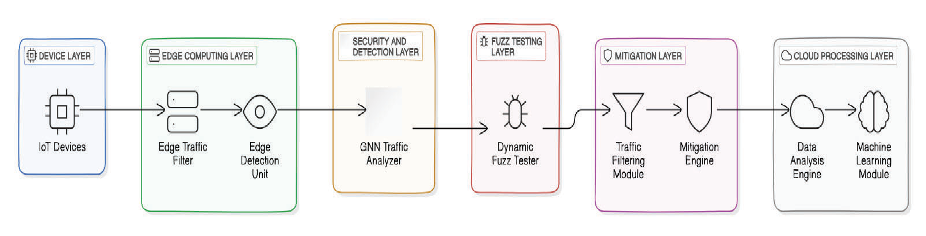

Fig. 3.1 Architecture Layers

# Core Components of FuzzAIoT

## Graph Neural Networks (GNNs)

GNNs form the backbone of the FuzzAIoT's real-time traffic analysis and DDoS detection. By modeling IoT devices and their communication as a graph, GNNs can identify unusual traffic patterns or communication anomalies. This graph-based approach enhances the detection accuracy of DDoS attacks by analyzing relationships between network nodes and their communication paths.

## Fuzz Testing Engine

The Fuzz Testing Engine continuously probes IoT communication protocols by generating dynamic inputs to identify potential vulnerabilities. It works closely with the GNNs to flag devices with weak protocols and take necessary measures to mitigate these risks. This engine ensures that devices are regularly tested for weaknesses that could be exploited in a DDoS attack.

## Traffic Filtering Module

The Traffic Filtering Module employs machine learning algorithms to classify and filter incoming traffic. This component plays a crucial role in distinguishing between legitimate traffic and malicious traffic during a DDoS attack. By ensuring that only safe traffic is allowed through, this module maintains network integrity while preventing overload during an attack.

## Mitigation Engine

The Mitigation Engine is responsible for implementing strategies that limit the impact of a detected attack. Techniques such as traffic shaping, blacklisting malicious IPs, and re-routing ensure that the attack traffic is minimized without affecting legitimate communications. This engine dynamically adjusts mitigation efforts based on the attack's severity and nature.

# Scalability and Performance Considerations

## Scalability

FuzzAIoT is designed to handle large IoT networks with potentially thousands of devices. The layered architecture and edge computing capabilities enable the system to scale efficiently without degrading performance. The distributed nature of traffic filtering and attack detection across edge nodes and the cloud ensures that the system remains responsive even as the network grows.

## Low Latency Operations

Latency is very important for real-time responses in IoT networks, particularly for such sectors as healthcare or industrial IoT. FuzzAIoT architecture minimizes latency at the architecture level, pushing the critical traffic analysis and filtering into the Edge Computing Layer. Mitigation thereby happens close to the source of data generation, hence minimizing the latency in attack responses.

## Adaptability

The system’s modular design ensures that new detection and mitigation techniques can be easily integrated. The architecture is adaptable to evolving attack vectors and future IoT technologies, ensuring that the framework remains effective in a rapidly changing threat landscape.

# Integration with Existing Infrastructure

## Cloud and Edge Integration

FuzzAIoT seamlessly integrates with both cloud platforms and edge devices. While the Edge Computing Layer provides real-time threat detection and response, the Cloud Processing Layer handles resource-heavy tasks, ensuring an optimal balance between latency reduction and data processing capabilities.

## Legacy System Compatibility

The system is designed to integrate with legacy IoT infrastructure, making it suitable for deployment in a wide variety of environments. It supports common protocols and communication standards, ensuring that even older devices can benefit from enhanced security without requiring significant system overhauls.

# Summary of System Design

FuzzAIoT’s layered architecture and modular components are built to provide real-time protection against DDoS attacks in IoT networks. The system’s reliance on Dynamic Fuzz Testing and Graph Neural Networks (GNNs) ensures proactive detection and mitigation of attacks while maintaining scalability, low latency, and adaptability for future IoT developments.

By dividing responsibilities across distinct layers—from the Device Layer to the Cloud Processing Layer— the architecture ensures efficient security measures at each stage of the data flow. Additionally, the system’s ability to integrate with existing infrastructure makes it a flexible and robust solution for securing diverse IoT deployments.